Directions for Using the Handheld Scanner Brand: VuPoint Magic Wand

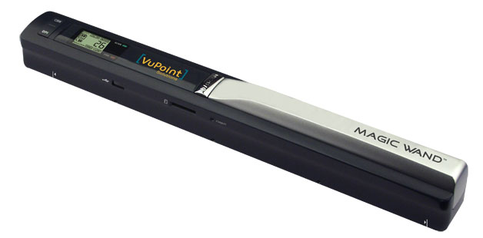
To Scan: DO NOT USE THE USB CORD YET!

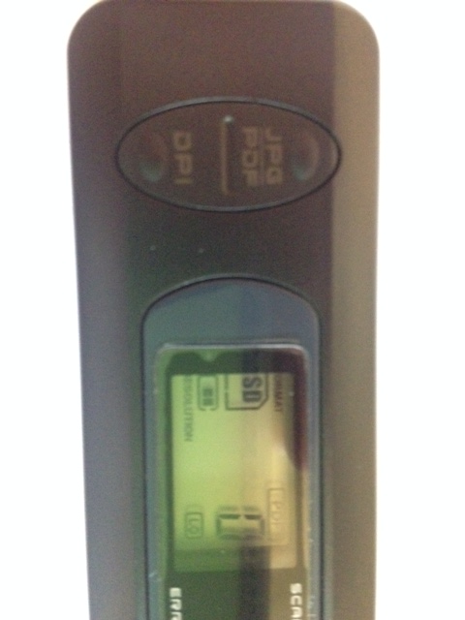
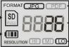
- Turn on the scanner by pressing and holding the “POWER/SCAN” button down for 2 seconds.
PDF
Highlighted!
- Be sure that the format button
Is selected to read PDF-not JPG!
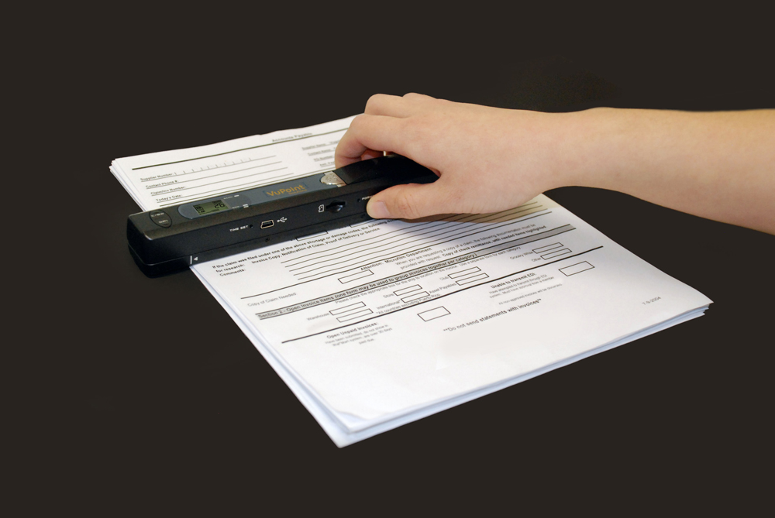
- Place the document on a flat surface and hold down the document with one hand.

- Place the scanner directly on the edge of the paper (approximately 5/8 to ¾ of an inch onto
the page to ensure the whole document can be scanned.
*Make sure to keep the scanning area in between the scanning width indicator marked on each side of the scanner.

- Hold the scanner flat against the document and then press the “SCAN” button once-the scan button will be green.

- Slide the scanner slowly, keeping your hand stable to get the best quality picture.

- Press the “SCAN” button again to stop scanning. The digital screen will tell how many pictures have been scanned. The green light should go off at this point.

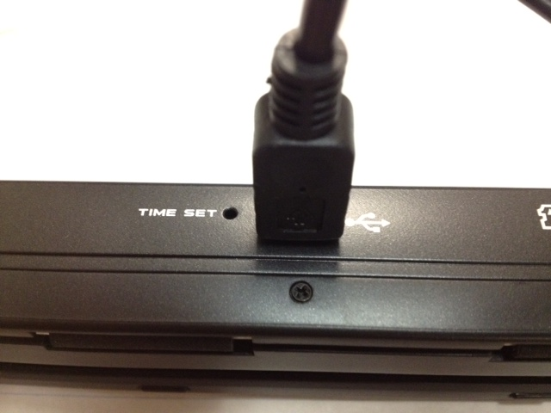
TO UPLOAD A SCANNED PICTURE TO YOUR COMPUTER: USE THE USB CORD NOW!

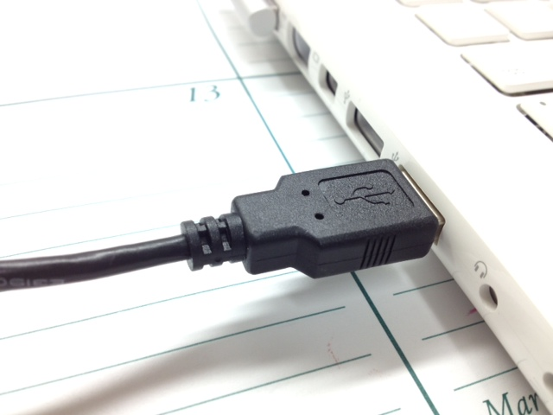
- Plug the smaller end of the USB cord into the scanner port. This port is located next to “time set” on the side of the scanner bar.

- Plug the large USB cord end into your laptop where there is a USB port.

- Turn the scanner on with the “SCAN/POWER” button. It will now say “USB” in the window.

- An icon labeled “NO NAME” should appear on your desktop. iPhoto may also automatically open on a Mac. You can download the pictures to iPhoto or close out of iPhoto (in the dock, you can force iPhoto to close by putting the cursor on iPhoto and holding down on the track pad clicker until you can select “force quit.”)
Go through the following steps:
- Double click to open the “NO NAME” driver.
- Select the folder labeled “DCIM.” Double-click on this folder to open it.
- Another folder labeled “100MEDIA” should appear. Double-click on this folder to open it.
- There should be a list of your scanned pictures in this folder.
- Drag the picture(s) to your desktop. You should rename the file according to your teacher’s directions or with some naming system so you can id the scan)
- You will upload this PDF file to your online course when asked to do so.
- Keep all scanned files in a folder or folders on your desktop until you know that your teacher has received them.

- To delete pictures from the “NO NAME” driver, go to the “100MEDIA” folder, select the pictures that you wish to delete. Drag them to the trash can in the dock.

TO DISCONNECT
- drag the “NO NAME” driver to the trash BEFORE removing the USB cord from the laptop.

TO TURN THE SCANNER OFF
- Hold the “POWER/SCAN” button down until it turns off.

