HANDOUT 2: Canvas Help Directions-Getting Started

Overview of Sections in This Handout:

- Log In
- Teacher Account Settings
- Personal Notifications Setting
- Customize Course List to Show Only Courses I am Using
- Rename sections to Period #
- Remove students from sections (periods)
- Add students to sections (periods)
- Side Navigation (IMPORTANT TO SET UP)
- Sending student/class a message (email)
- Student Access Report
- Speedgrader-link to online demo videos

1. How Do I Log In?
- Go to: https://punxsy.instructure.com/login (Link can also be found on left navigation of school website)
- You may also bookmark it for easier access or create a shortcut icon by dragging the URL onto your desktop
- Username & password should be the same that you use for accessing your school email

2. How Can I Configure the “Teacher Settings” for My Account?
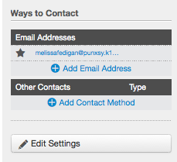
- Click on “settings” to the right of your name in the top, right corner.

- In the “Ways to Contact” option on the top, right side, make sure your email is listed. If it is not listed or is not correct, select the “add email address” & type your email. You cannot remove your school email from your account.
*You may also add another email if you choose.

- There are also “other contacts” you can use. You may set this up if you want to be contacted another way.

3. How Do I Change My Personal Notifications?
- Click on “settings” to the right of your name in the top, right corner.
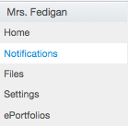
- Go to “Notifications” on the left side-select

- In the list of Notification Preferences…
There are 6 groups of notifications. You will need to set ALL notifications. Keep in mind the following:
When you hover over a cell, four icons appear.
1. By selecting the Checkmark icon, you will be immediately notified of any change for the activity.
2. By selecting the Clock icon, you will be notified daily of any change for the activity.
3. By selecting the Calendar icon, you will be notified weekly of any change for the activity.
4. By selecting the X icon, you will remove the notification preference and will not be notified of any change for the activity.

SUGGESTED CHANGES…
- Course Activities—change: (Leave all others blank so you don’t receive notifications!)
  - “All Submissions”-daily (I would NOT select ASAP. You will be flooded with emails every time a student submits something graded to you)
  - “Late Grading”-daily or not at all
- Discussions—change: (Leave all others blank so you don’t receive notifications!)
  - Discussion Post-daily if you are using this feature
- Conversations—none
- Scheduling-none
- Groups-none
- Alerts-none

4. How Do I Customize My Courses List?
*You need to access your SIS class schedule and rosters (either print out or have a tab open.)

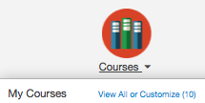
- In Canvas, go to Courses in top (Global) navigation bar—select “View All or Customize”

- In this list you will see all the courses that are associated with your name in our SIS system. There maybe many more courses listed than you actually teach.
- You will need to log into SIS to match up the course ID and section with the description in SIS.
CANVAS COURSES: SIS IDs:
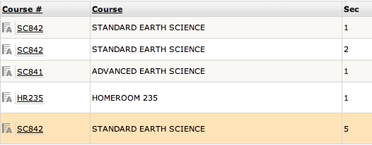
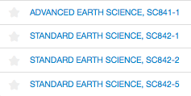
# after name in Canvas= course ID in SIS

# after course ID=section ID in SIS
ID what period # each section is in SIS

- Once you have identified the courses that you actually teach, you can click on the “star” beside the course in your list in Canvas. This will customize your course list to only show the courses you teach from the Global Navigation link from now on.

5. How do I Rename a Section of My Course to the Period #? (click on link for directions or see steps below)

http://guides.instructure.com/m/4152/l/57095-how-do-i-change-the-name-of-a-section

- Select a course that you are currently teaching from “My Courses.”
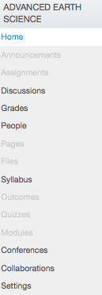
- Go to “Settings” on bottom, left-side navigation.

- Select the “Sections” tab. You will see a list of all “sections (periods)” in your course.

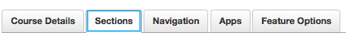

- Click on the course name—this will bring up your course with a list of students enrolled under it.
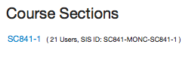
- Go to the “Edit Section” button at the top, right. 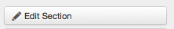
- You NEED TO edit the “Section Name” –UPDATE SECTION with Period 1 or something similar—
DO NOT use the course name—It will already be listed
*Repeat these steps for each section until all are renamed with a period #.

6. How do I Remove Students from a Section (class period)?
- Check your class lists against your SIS list while you are in each section by scrolling down the list.
- Make a note of students who need to be removed from a section (class period).
*Note: You cannot add a student to another section in your course until the student is deleted/concluded first from the section he or she is listed in first.
- Select “People” on the left side navigation.
- You will see an alphabetical list of all students in your course (all class periods).
- Click on the student’s name
- Select “More User Details” below the Name and Email box
- In the “Membership” Box, select “Conclude this Enrollment”-all work will be saved in case you need to enroll the student into your course again (ie Placement, move and then come back)
- Continue to remove students until finished.

7. How Do I Add Students to My Course/section?
*Be sure that you are in the course for which you want to add students.

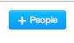
- On the left-side navigation, select “People.”
- The “everyone” tab should be selected—go to the blue button labeled “+ People”

- A new window will pop up.
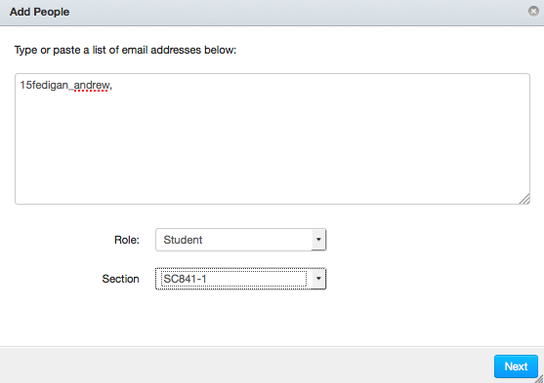
Type the names of the students according
to each student’s log in name:
i.e. 15smith_joseph

- 16 (seniors)
- 17 (juniors)
- 18 (sophomores)
- 19 (freshmen)
- 20 (8th graders)

*You may add multiple students by separating names with a comma. Ask students what their log in name is if you are unsure of graduation year.

- Select “Role”-student- from the drop down menu.
- Select the section for the enrollment from the drop down menu. (Your section should be renamed with the period #).
- The next window will ask you to validate the enrollment or show you errors if the user is not in the system or was typed incorrectly. Try to retype the username.
- All students should now show up in your section.
- Students who are added, will be asked to “accept or decline” the invitation. Prompt them to “accept.”
*NOTE: If you cannot add a student, email Melissa Fedigan for help!

To Add a Teacher to your Class…(co-teaching, etc.)
NOTE: You may also add another teacher to your classes the same way you add students.
- When entering a teacher’s name, use the email log in name (i.e. ldondon, mfedigan, etc.).
- Make sure to select the correct section from the drop down menu and select “Teacher” as the role if you want another teacher to have editing rights.
- Or select “observer” if you want the teacher to see what is going on in the course but do not want them to edit content or grade student work.
- Observer or Teacher/TA roles allow you to also include the teacher in messages you send to the class or individuals.
- A teacher role will also permit you to roll parts of one teacher’s course over to your courses if needed.

8. How do I set the Side Navigation for my students? (IMPORTANT STEP!)
*This step is necessary so that students do not accidently have access to components that you don’t want them to have access to until you release it to them!)
- Go to “Settings” on bottom, left side navigation.
- Select the “Navigation” tab.
- Drag all items to the bottom so they are listed under the hidden section except—KEEP:
- Home
- Modules
- Announcements
- Discussions
- People (If you plan to use Canvas for group work-this can also be set up anytime)
- Grades

9. How Do I Send My Students a Message in Canvas?
- Select “inbox” at the top right of your Canvas page (These are actually called “conversations” but work like email inside Canvas)
- Select the “compose a new message” icon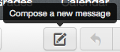
- Select a course from the drop down menu-this may take some guesswork if you have many courses.
- You can just start typing a name if you are sending to one or a few students or go to the address book at the end of the “To:” line to select all your students, a section of your students, or an individual in a section.
- Complete the subject line.
- Compose your message. You may also include attachments by clicking on the paperclip at the bottom of the message.
- Send!

10. How Can a Teacher Check on Student Activity in a Class?
- Go to "People" on the left side navigation.
- Search for the student's name and click on it.
- In the new screen on the RIGHT side, select the "Analytics" button or the “Access Report.” You will see information about how often the student is accessing activities in your class.

11. How Do I Grade Using Speedgrader?
Link: How to Access Speedgrader
http://guides.instructure.com/m/4152/l/55016-how-do-i-use-speedgrader
Link: How to Evaluate Using Speedgrader
Click on links for directions (video demo here too):
http://guides.instructure.com/m/4152/l/55021-how-do-i-evaluate-assignments-in-speedgrader

