Canvas Helpful Tips Guide for Modules:
Editing Homepage, Modules, & Building Assignments

*Use browser of your choice (link to Canvas on District Homepage left navigation-first choice)
https://punxsy.instructure.com/

Getting To Course Content:
- Select the course you want to build from the “courses” icon in the top navigation.

Editing Homepage:
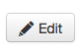
- To get to the Homepage for your course, click on the word “Home” in the left navigation.
- Click on in the top right of the page.
- In the textbox, highlight the text that is there and replace it with your information.
- Upload a picture file to replace the picture that is there at a later time or keep this one.
- You can copy and paste from the curriculum guide for your description of the course or you can type your own description.
- Add anything else you would like students to know.
- SAVE

Editing Module Names:
- Click on “Modules” in left navigation—you will see all the modules with generic labels
- Start with Module 2 (name it what you are currently doing in your class)-You should not keep the word “module” or the number in the title.
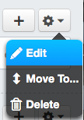
    - The “Gear icon” to the right of the module has a drop down menu:

    - Select “edit” to change the name of the Module for your course—you can rename to the title of the chapter, unit, section, or week.
    - You should continue with other Modules in the same manner by editing the name to fit your course content. You can always move modules around later so that your course makes sense from the beginning to the end.
    - SAVE each time.

Adding Assignments to Course Modules:
- Click the “+” next to the Module you want to add the assignment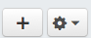
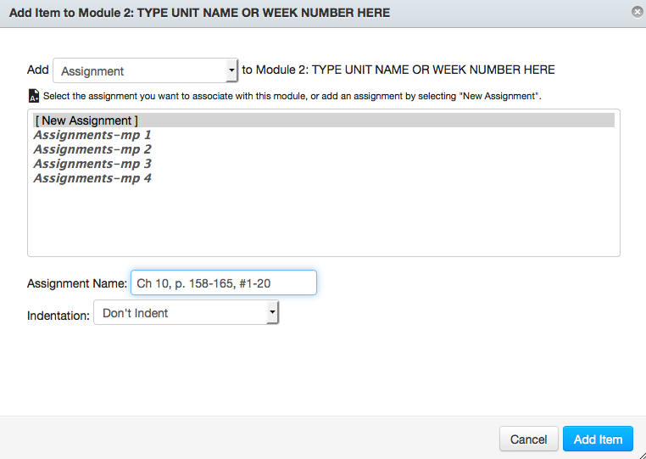
- Add “Assignment”-Make sure drop
down says Assignment
- Select [New Assignment]
- Name Assignment as you would in SIS
- Select “Add Item.” The “shell” for the
Assignment will now be listed in your module.
- Repeat for each additional assignment.
Adding Content to the Assignment Shell:
- Click on the actual name of the assignment listed in the module.
- Select the “Edit” button to add details to the assignment.
  - To add Directions to an Assignment: Either (1) type the directions or
(2) copy directions from a file that you have and paste into the textbox.
Use bulleted lists when possible.
  - Add files/videos/hyperlinks/etc. to the assignment in this text area.
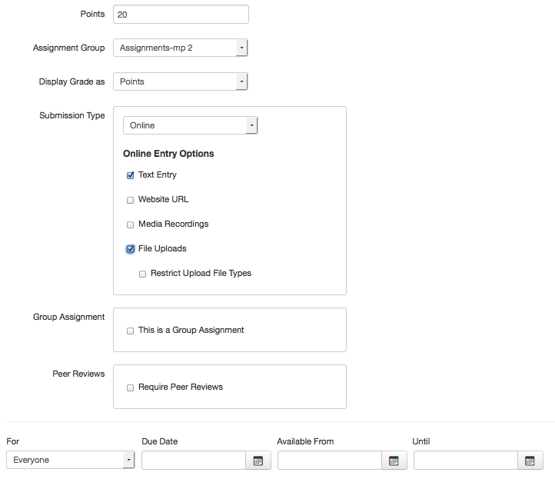
  - Set the point total
  - Set the marking period it is in
  - Display Grade is always “points
  - Submission Type: Select “Online” -Text Entry or File Upload--selecting both options is fine
  - Leave blank for now-advanced
features
  - Leave the Due Date blank (can be
added from the calendar or fill in Due Date
here.) Leave access dates blank.

To Add a File to an Assignment:
    - Open up the assignment and click on the “edit” button.
    - Type any directions or text that you want, such as:
- Download the study guide and complete it.
- Turn your completed guide in to me or online by the due date.
    - Make sure your cursor is in the textbox where you want the file to be added.
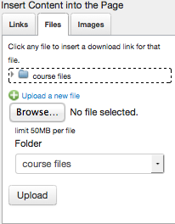
    - Go to the right side of your screen and select the “file” tab under “Insert Content into the Page:”
    - Find the file if you uploaded it or “Upload a New File”
    - Browse to find the file you want on your laptop
& click on it-select upload to move the file
into Canvas--a link will be created automatically in
the assignment, too.
    - Click Update Assignment

Adding Discussions to Course: (not in Modules)
- Click “Discussions” link on the left
- Click “+ discussion” button
- Type in the name of the discussion
- Copy and paste the directions or type the directions if you don’t have an electronic copy already.
- Check users must post before seeing replies
- Check graded
- Assign points
- Click save

Adding Assignments/Discussions/Etc. to Modules:
*You can attach assignments and discussions and quizzes that you have already made following these directions.
- Click Modules
- Select the Module you want to add to
- Click + button
- Select “assignment” from “Add” drop down menu for assignments (or discussions or whatever you are adding)
  - Highlight assignment
  - Click indent if you choose to have it indented
  - Click “add item”
- Select “discussion” from “Add” drop down menu for assignments (or discussions or whatever you are adding)
  - Highlight the discussion you want to add
  - Click indent if you choose to have it indented
  - Click “add item”
*You can also create new items from scratch from this menu—instead of selecting an item you have made already, select “new _______” to build the assignment, discussion or quiz right in the module as you go along.

(SKIP UNTIL LAST) Editing Overview Page to Module:
*This may be completed LAST--after you have added content (assignments, discussions, quizzes, etc.) to your modules. Completing this page last will help you fill in the blanks for what you are covering in this module. So, build the content first then write the overview page.
- Click on the words: Overview Page
- Click “edit”-located at top right
- Highlight text you want to delete or reword & select “delete” on you keyboard
- Add your information for the unit/chapter (Make this friendly and easy to understand. Do not fill it with objectives or other text that isn’t relevant to students.)
- Click SAVE

