How to Undelete items in Canvas that are Accidently Deleted!

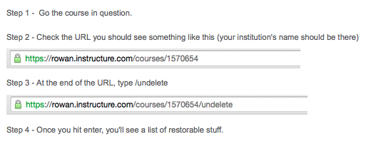
*You will see all the items you have deleted. There is a “restore” button that will put the items back into your course—including graded work for students if they already submitted the assignment, test, etc.

