Examview “Points Issue” for Questions

PART 1: Exporting & Locating the File to Edit
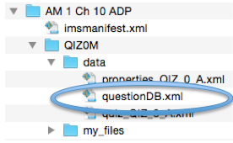
- Follow the directions for how to export a file from Examview.
See the Canvas Teacher Resources Page for this document: http://www.punxsy.k12.pa.us/Page/5591
- Locate where you saved the exported “.zip” file from Examview.
- Click on the “.zip” file to unzip it into a folder. (You should trash the “zip” file now.)
- In the folder with the Examview files, open the “QIZOM” folder.
- Open the “Data” folder, which is located inside this “QIZOM” folder.
- Open the “questionDB.xml” file (This file should open with Text Wrangler).

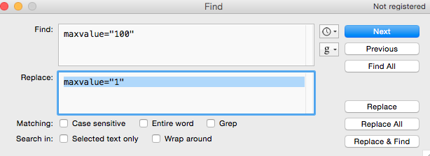
PART 2: Changing Points
- In this window filled with code, you should type: “Command + F” (a keyboard shortcut for Find) to search for the code you will need to replace.
- Once in the “Find” window, type or copy/paste: maxvalue="100"
- Next, paste this: maxvalue="100" into the “replace” window. You will change the 100 to a 1 for points (maxvalue="1")
NOTE: You can replace this number with any other number in case you want all points to be worth 2 or another value.
- Select “Replace All.”

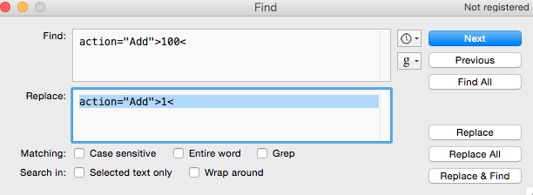
PART 3: Changing Points continued (You will probably already be on this window)
- Go back to the “Find” window again (“Command + F”)
- Type or copy/paste: action="Add">100<
- Next, paste this: action="Add">100< into the “replace” window. You will change the 100 to a 1 for points (action="Add">1<)
- Select “Replace All.”
- Close the "Find" window where you made your changes.
PART 4:
- Save the changes to the file in “Text Wrangler” (File-save)& Close this window/application.
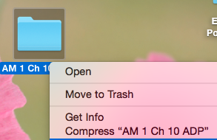
- The main folder that holds the file with the changed point totals for questions must be turned into a “.zip” file in order to upload THIS new “.zip” file into Canvas.
- If you did not earlier, you need to trash the old “.zip” file so you are not confused (It has the old point totals).
- Click 1 time on the blue folder to highlight it.
- Use the “Control” key + “click” on your trackpad” for a left dropdown menu to appear.
- Select “compress…whatever the folder is named.”
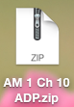
- You will browse for this new “.zip” file to upload into your Canvas course and the points will now be correct!

- You can find the file under “quizzes” in your left side navigation in Canvas. When you preview it, the questions should now be correct. Please be sure to rename the quiz since all Examview Imports are called “Unnamed Quiz.”

