How do I create an Assignment shell from the Calendar?

https://community.canvaslms.com/docs/DOC-1972

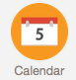
You can create Assignment shells from the Calendar. Assignment shells are placeholders for the Assignment until you fill in the Assignment details. You can create varied due date Assignment shells via the Calendar too.

Open Calendar—Global Navigation icon
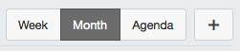
- Add Assignment—Click the Add icon.

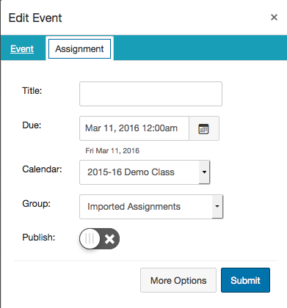
- Enter Assignment Details
- Enter a title and due date for the new assignment.
- In the Calendar drop-down menu, select the course for the assignment.
- In the Group drop-down menu, select the assignment group.
- To publish the assignment, toggle the Publish icon.
- If you choose not to publish, the assignment will still be created and remain unpublished.

- Click the Submit button [6].
Note: To edit the assignment details, click the More Options button [7].

How do I create an Event in the Calendar?
- Follow the directions for adding an assignment, but be sure to select the Event Tab.
- Files, links, and other resources can be added to an event by selecting the More Options button.
- NOTE: Events do not have points associated with them. Events will not show up in the Gradebook view.

