Creating a Duplicate Test/Quiz in Canvas to Create a Pre/Post test
*Much easier to do if you create duplicates BEFORE students take the quiz/test.

1. Go to your settings and Choose “Import Content into this Course” found along the right side.

2. Select “Copy a Canvas Course” from the dropdown.

3. You want to choose your current course to copy. You are not actually copying the whole course; you will just be choosing the items you need from the course.
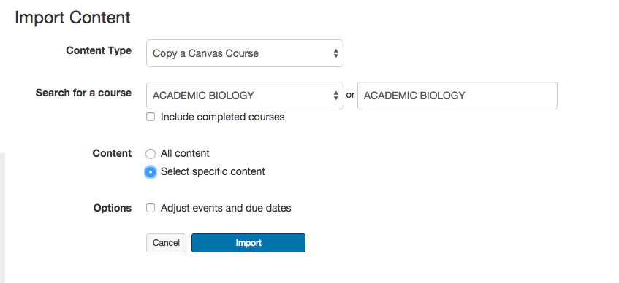
4. Click the “Select Content” button to choose what you want to copy from that course.
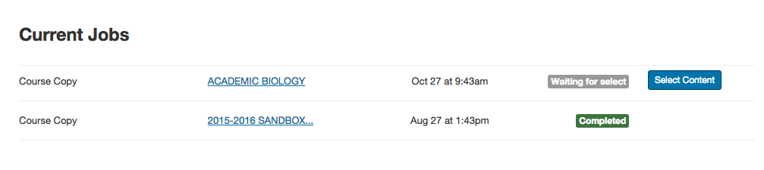
5. Select the item you want to copy. You can choose from whole modules, assignments, quizzes, etc. For example, I want a current test to also serve as a pre-test and will choose the test that I want copied.
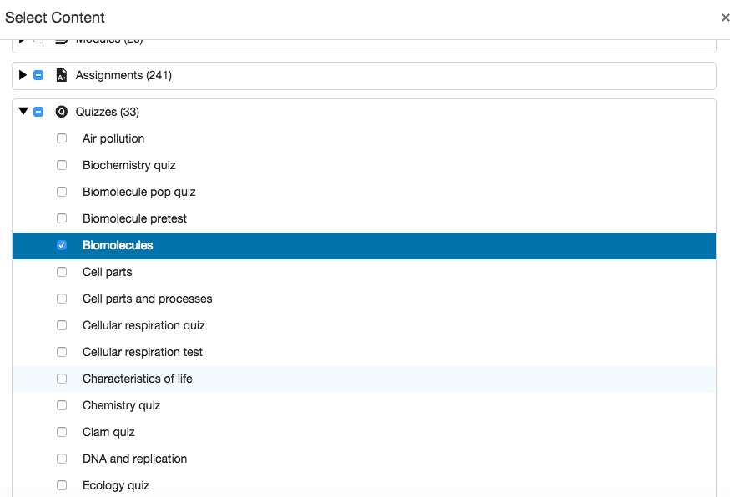

6. When it has been imported, it will show as completed.

7. To find your copied quiz, you can click on Quizzes along the left side and you will see both listed.

8. Click on one of your quizzes to change the name to “pre” or “post” or another name.

9. You will need to add the newly imported quiz or quizzes to the correct module(s).

10. Go to “Modules,” select “+” to add content—drop to “Quizzes”-find and add your quiz. You may also need to move it within the module, because it will be added to the bottom.

