Canvas Quiz Security: Quick Guide Settings
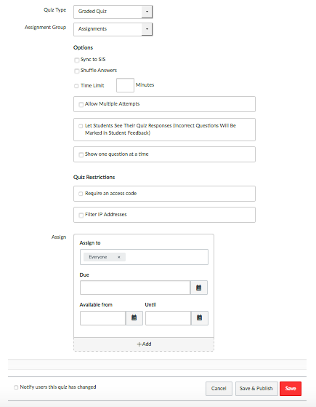
The “Assign” option should have a Due date so that it shows up on the calendar and the gradebook.
You can limit the availability of the quiz by adding an “Available from” and/or “Until” dates.
*”Available from” may be left blank. The quiz will then be visible when the teacher publishes it.
*If the “Until” date is past the due date, students can still access the test, but it will show up as Late in Speedgrader.

Try requiring an access code for extra security. You may want to consider quickly changing the code after each class & again after the last class for absent students.
Keep this box UNCHECKED until All Students have taken the Quiz.
Do NOT sync to SIS unless you are in the test group of teachers.
Be sure that your quiz is created in the Assignment Group—“Assignments”

Important Message: Quiz availability (dates/times) have NOTHING to do with whether a student can view quiz results. The ONLY way to stop students from viewing quiz results is to have the “Let Students See their Quiz Responses” and “Show which answers were correct” boxes UNCHECKED.

You may also want to consider “muting” the quiz in the “grades” view. By selecting “muting” students cannot see a grade or have access to the assignment/quiz until you “unmute” it.

