Canvas Quiz Settings to Maximize Security: Detailed Guide
This is a comprehensive list of Canvas Quiz Settings and Information on how to maximize quiz security. There are many options you can use. I have highlighted the settings to make your online quiz the most secure.

Shuffle Answers – This is a checkbox option under quiz settings and will randomize the order of the question's answer choices. By using “shuffle answers” students may get the same quiz question(s), but their answer options probably won't be in the same order.
**If your quiz question has an answer like “all of the above/below” or “answer A & C” do not use the “shuffle answer” setting.**
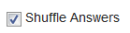
Time limit – This is a checkbox option under quiz settings and limits the amount of time students have to take a quiz. When deciding on a time limit try to estimate the average time a student should need to answer each question - taking into account different types of quiz questions. If quizzes are given in a non-proctored environment the time limit can be used to cut down on the amount of time students have to look up question answers and/or share the questions with other students. If a student needs extended test time this can be added per individual student under the Moderate Quiz settings.
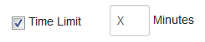
__________________________________________________________________________________________
Allow Multiple Attempts – This is a checkbox setting that allows students to have multiple attempts to take a quiz. From the multiple attempts Instructors can decide which quiz score to keep: Highest, Latest, or Average. If the number of allowed attempts is left blank, then students will have unlimited attempts that would only be stopped by the "Until" date/time.
*In general, unless there is a large question bank of questions and/or your goal is mastery of the content, multiple quiz attempts does not create a secure quiz environment.
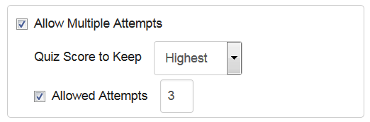
**(DO NOT DO THIS)** Let Students See Their Quiz Responses – This is a checkbox option under quiz settings and after a student submits a quiz allows them to see (1) the quiz questions & answer options, (2) the answer options the student selected, (3) if they got a question incorrect or partially incorrect and (4) ALL question feedback. This information will be shown regardless of the due & until dates and even if the correct answers are NOT made available (via the “Let Students see the Correct Answers” setting). *For enhanced quiz security leave this box unchecked altogether or leave it unchecked until after the “Due’ and ‘Until’ date(s).

The following options only appear if the "Let Students See Their Quiz Responses" box checked:
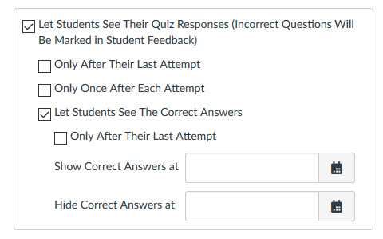
Only After Their Last Attempt - This checkbox option only shows up if the quiz is set to allow multiple attempts with a specific number of attempts; this option does not show up if there are unlimited attempts. If this box is checked students will NOT be able to see any quiz results other than the score they got on each quiz attempt until they take the quiz for the last time (as designated by the number of allowed attempts). After they take the quiz for the last time the students will then be able to see (1) the quiz questions & answer options, (2) the answer options the student selected, (3) if they got a question incorrect or partially incorrect, and (4) ALL question feedback.
*If you are using multiple attempts, this is the best setting to use to keep the quiz secure. Yet, this information can't be controlled by a date/time, so a student could use all their attempts, get the question information, and then share the information before the due/until date(s).
Only Once After Each Attempt - This checkbox option allows students to see (1) the quiz questions & answer options, (2) the answer options the student selected, (3) if they got a question incorrect or partially incorrect, and (4) ALL question feedback, but only ONCE after they have submitted a quiz. In a proctored environment this is a useful setting because students will get to see feedback from the quiz, but it is only visible immediately after submitting the quiz. If students go back to the quiz they will see their scores for the quiz, but none of the other quiz information (1-4 above) will be visible.
Let Students see the Correct Answers - This checkbox option allows students to see the correct answers to quiz questions. If this box is checked students will have access to (1) the quiz questions & answer options, (2) the answer options the student selected, (3) which answer option was correct, and (4) all question feedback. For enhanced quiz security the best option is to leave this box unchecked (along with the “Let Students See their Quiz Responses” option) until after the “Due” and “Until” dates and then also limit how long the students can view the correct answers.
Only After Their Last Attempt - this checkbox option under "Let Students see the Correct Answers" only shows up if the quiz is set to allow multiple attempts with a specific number of attempts; this option does not show up if there are unlimited attempts. If this box is checked students will NOT be able to see which answer options were correct until after their last attempt (as designated by the number of allowed attempts). After they take the quiz for the last time the student will be able to access (1) the quiz questions & answer options, (2) the answer options the student selected, (3) which answer option was correct, and (4) all question feedback for as long as designated. For enhanced quiz security the best option is to leave this box unchecked (along with the “Let Students See their Quiz Responses” option) until after the “Due” and “Until” dates and then also limit how long the students can view the correct answers. Note: This setting also overrides the "Show Correct Answers at" date. If you want correct answers to be released or hidden on a certain date/time or do NOT check this box.
Show/Hide Correct Answers at - this option allows students to see the correct answers to quiz questions starting at the designated "show" time and hidden again at the designated "hide" time. The show and hide options can be used independently of each other or together to create a window of when correct answers are visible to students. If one or both dates are provided students will have access to (1) the quiz questions & answer options, (2) the answer options the student selected, (3) which answer option was correct, and (4) all question feedback - during the time frame designated by the show/hide dates/times. For enhanced quiz security the best option is not use this until after the “Due” and “Until” dates and then also limit how long the students can view the correct answers. Note: If you want to use the show/hide correct answers option then do NOT check the "only after their last attempt" box directly above it, it will override your date settings and make quiz answers visible to students after their last attempt.

Show One Question At a Time - This is a checkbox option under quiz settings and allows students to only see one quiz question at a time. It is recommended to use this feature in conjunction with the "Lock Questions after Answering" option. Used together, it requires the student to answer each individual question before moving on and prevents students from going back and changing their answer. **Students do NOT like getting one question at a time and especially if they are prevented from going back and changing their answers, so make sure you really want to use this option before implementing.**
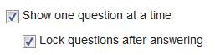

Require an access code - This is a checkbox option under quiz settings and prevents students from taking the quiz without the correct code. This feature can be used to make sure students are taking the quiz at a specific time or in a certain location; this works especially well for students who need to take a test in the Testing Center or with a proctor. This setting can also be used if students have started taking an untimed quiz in class (or a proctored environment) and don't finish it in one class period and need to come back to class to finish it. The Instructor can add (or change) the access code after the quiz has started and it will completely lock the students out of the quiz until the student enters in the new access code.
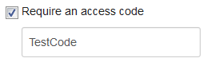

Filter IP Addresses - This is a checkbox option under quiz settings that can be used to make sure students are taking the quiz in a specific location. This works especially well for students who need to take a quiz in the Testing Center or with a proctor in a secure environment. **To use this option you will need to talk to your Canvas Admins so they can coordinate things.**
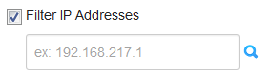

Quiz Availability - In general to maximize quiz security it is best to have a quiz open the least amount of time as possible. Below is information on the quiz availability options and how they can be used to enhance quiz security.
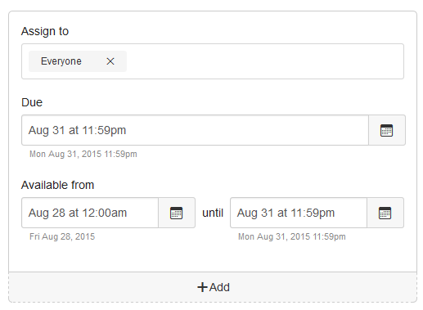
Assign to - In courses with multiple sections this feature allows instructors to designate the availability settings by course section or individual student(s). In general, unless you have students in different sections taking the quiz at different days/times, this would be left as “Everyone” (which is the default). This feature can’t be used with students who need testing accommodations or who are in different groups. For students who need different availability than the rest of the class it is recommended to manually unlock the quiz using the Moderate Quiz settings in conjunction with an Access Code.
Due – This is the day and time that the quiz is due. This does not stop students from taking a quiz, but quizzes submitted after the Due date will be marked as late in Speedgrader and in the Gradebook. Recommended practices for quiz security are to not allow students to take a quiz after the Due date; this can be done by making the Due date and Until date the same. If students are allowed to take quizzes after the “Due” date, then leave the "Until" date blank or set to the furthest day/time late submissions are allowed.
Available From – This is the day and time the quiz becomes available to students. Students will not be able to access the quiz before this day and time unless the quiz has been manually unlocked; manually unlocked is available under the Moderate Quiz settings. In general, if a student or students are taking the quiz early the time will need to be set to when the first group of students is taking the quiz. This is also when it's a good idea to use the "Require an Access Code" option to keep the rest of the students out of the quiz until they should have access to it. **If a quiz is not published (has a gray cloud instead of green) then students WILL NOT be able to access or even see the quiz, even after the "Available From" date.**
Until – This is the day/time that the students will no longer be able to take the quiz. If the Until day/time is set beyond the "Due” date" students will still be able to take the quiz until the “Until” date, but it will show up as "late" in SpeedGrader and the gradebook. If a student is in taking a quiz Canvas will auto-submit the quiz at the "Until" date/time regardless of whether the student is in taking the quiz or not. If there is no "Until" date set then the quiz will not auto-submit until the end of the course. For enhanced security instructors should set the “Until” date to be the same as the “Due” date because it prevents students from taking the quiz after it is due. Yet, this can also cut students off in the middle of taking the quiz because the "Until" date will automatically submit the quiz.
Important Message: Quiz availability (dates/times) have NOTHING to do with whether a student can view their quiz results. The ONLY way to stop students from viewing their quiz results is to have the “Let Students See their Quiz Responses” and “Show which answers were correct” boxes UNCHECKED. If you want students to initially see their quiz results, these boxes can be checked and set to close once you no longer want students to view the quiz results.

Preventing Students from Viewing Quiz Scores
The only way to prevent students from viewing their quiz score at the end of a quiz is to mute the quiz before the students take the quiz. Please note though, muting an assignment will override your other quiz settings related to quiz feedback. Students will not see any quiz feedback including their responses to questions or the correct answers. Instead students will only get this message (see image below).
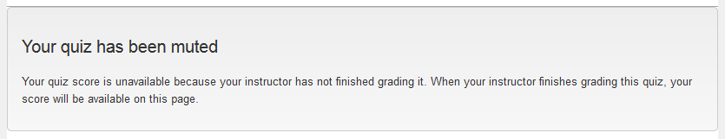
Once the quiz is unmuted, students will be able to see/access quiz feedback based on the the quiz settings.

I used this link from Canvas with some modifications:

Jones, Kona. “Quiz Settings to Maximize Security.” community.canvaslms.com, 12 ed. Canvas, 24 Feb. 2017.
https://community.canvaslms.com/docs/DOC-3313-quiz-settings-to-maximize-security. Accessed 10 Apr. 2-17.

