To Make a Quicktime Video of Your Laptop Screen with Audio

If you need to record a lecture or a lesson using your laptop/whiteboard and want to capture the audio along with it, please follow these directions below:

- Search for “Quicktime Player” on your laptop-either use “spotlight search” or your application list.
- Launch Quicktime Player.
- On the File menu, select 1 of 3 choices: new movie, audio, or screen recording.
- Go to “New Screen Recording,” and set it up to look like the picture below:
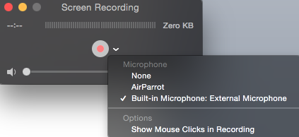
Be sure to select the symbol by the record button to make sure you have AUDIO turned ON if you want to record your voice along with the laptop screen.

- You will be able to record anything you are doing on your screen, including running apps like RM Easiteach or your white screens on the Eno or Polyvision boards.
- You may have video at the beginning and end that you don’t really want due to starting the recording and then needing to open the app and then closing it at the end to stop the recording.
- If this doesn’t bother you, leave it.
- If you want to edit the clip, go to “Edit” & select “Trim.” (simple process).
- You can save the video as an “.mov” file.

*If you need to upload the movie to Canvas, there are some options for making this accessible for your students. See Mrs. Fedigan for help.

