Creating a Duplicate Test/Quiz in Canvas to Create a Pre/Post test

1. Go to your settings and Choose “Import Content into this Course” found along the right side.

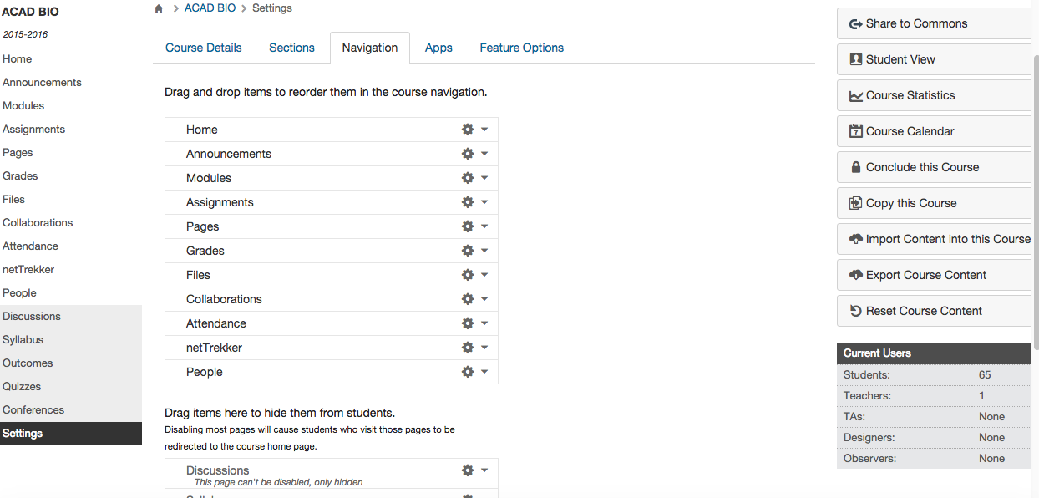

2. Select “Copy a Canvas Course” from the dropdown.

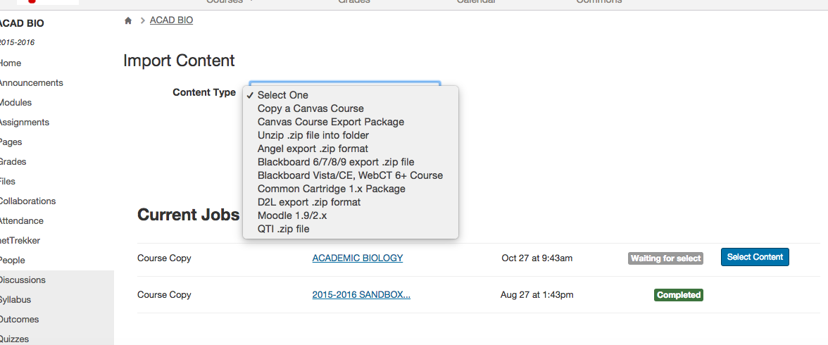

3. You want to choose your current course to copy. You are not actually copying the whole course; you will just be choosing the items you need from the course.
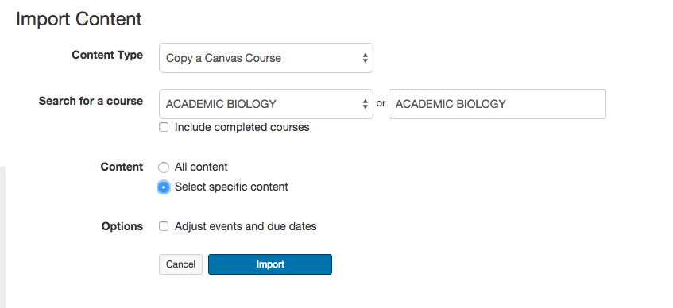

4. Click the “Select Content” button to choose what you want to copy from that course.
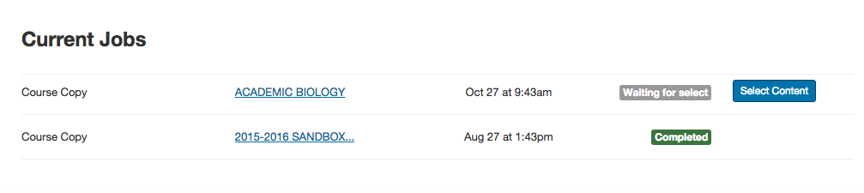

5. Select the item you want to copy. You can choose from whole modules, assignments, quizzes, etc. For example, I want a current test to also serve as a pre-test and will choose the test that I want copied.

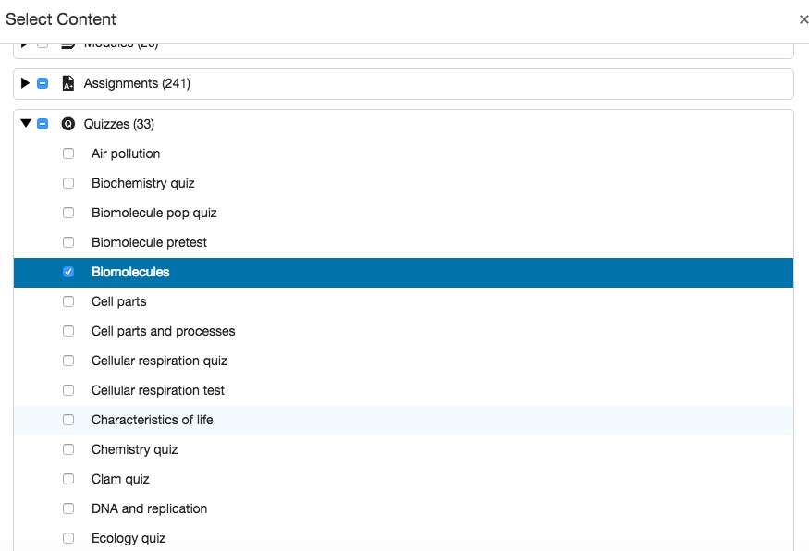

6. When it has been imported, it will show as completed.

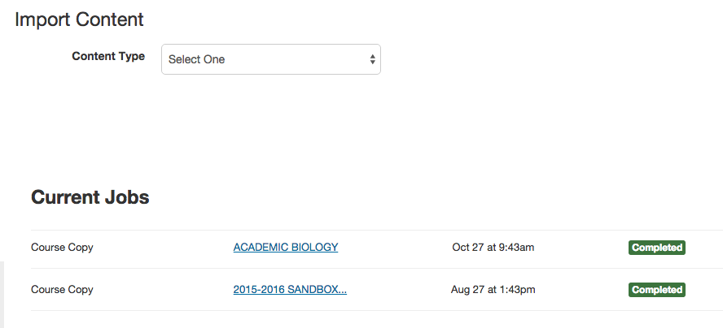

7. To find your copied quiz, you can click on Quizzes along the side and you will see both listed. One still exists in your correct module under the correct marking period (Assignment 1, etc.). The other is found under “Imported Assignments” and is not yet assigned a marking period.

8. Click on one of your items to find the imported version.

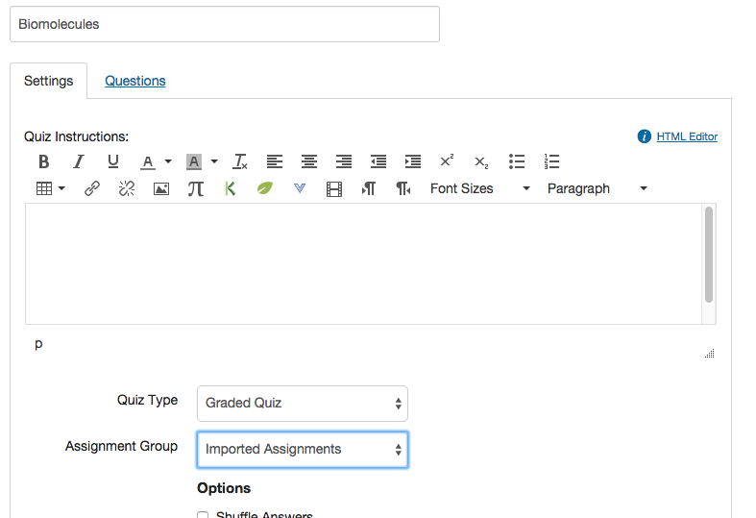

9. Change it to the correct Assignment category.
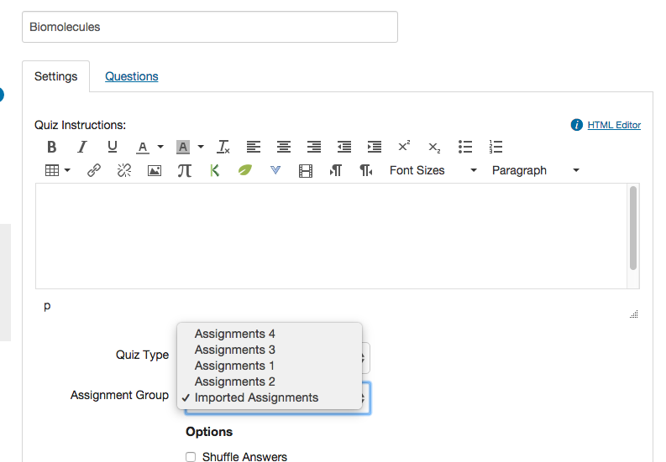

Note: Instead of 7 through 9, another option would be to go into your module, click the + button and add your new assignment/quiz and find the new import and change the settings there.

