How do I add a Rubric to a Graded Discussion?

https://community.canvaslms.com/docs/DOC-2899
- Open Discussions—In Course Navigation, click the Discussions link.
- Open the Graded Discussion by clicking the discussion title.
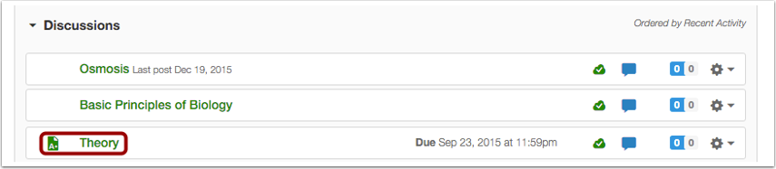

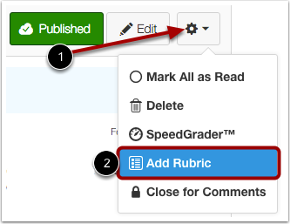
- Add Rubric
Click the Settings icon [1] and select the Add Rubric option [2].

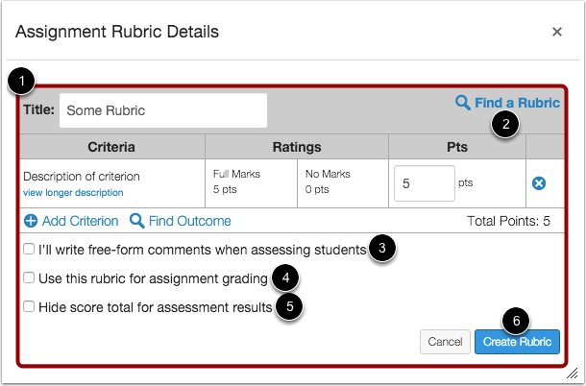
- Create Rubric

- Create a new rubric for your quiz [1].
- You can also find an existing rubric by clicking the Find a Rubric link [2].
- If you want to write free-form comments to students, select the I'll write free-form comments... checkbox [3].
- If you want to use the rubric for grading, select the Use this rubric for assignment grading checkbox [4].
- If you don't want students to see the score total for the rubric in their quiz results, select the Hide score total for assessment results checkbox [5]. Students can still see the point values for each criterion, but the total score will not be shown at the bottom of the rubric.
- When you are finished, click the Create Rubric button [6].

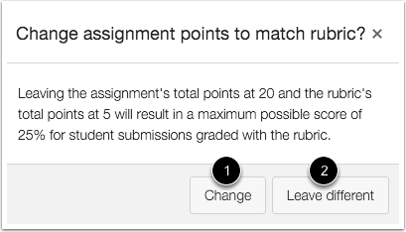
Use Rubric for Grading

If you select the option to use the rubric for grading, Canvas will compare the rubric score and Discussion points.
If the number of points in the rubric is different than the number of points in the Discussion, Canvas will generate a warning message notifying that the point values are not equal.
Click the Change button [1] to return to your rubric and make adjustments. Otherwise, click the Leave different button [2].

View Rubric
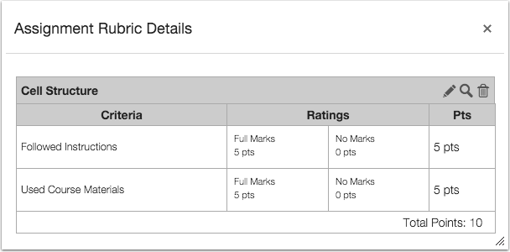

View the rubric for the graded discussion. If necessary you can edit the rubric.

