How do I create a Discussion as an instructor?

https://community.canvaslms.com/docs/DOC-1977
As an instructor, you can create a discussion for your course.
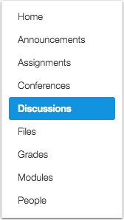
- Open Discussions

- Add Discussion—Click the Add Discussion button.

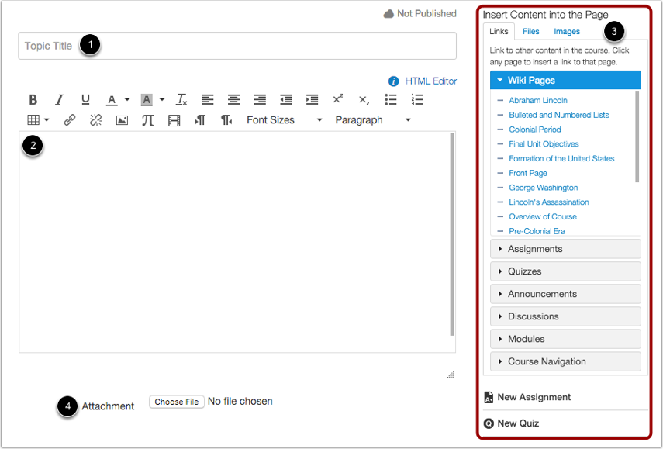
- Create Discussion

- In the Title field [1], create a title for your discussion.
- Use the Rich Content Editor [2] to create content for your discussion.
- You can also add links, files, and images to the discussion using the content selector [3].
- You can also add an attachment to your discussion by clicking the Choose File button [4].

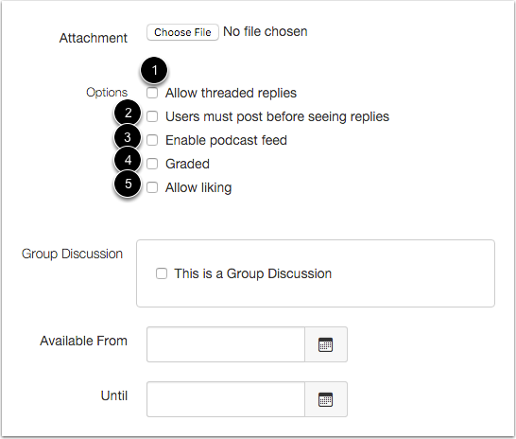
- Add Discussion Options

- By default, discussions are created as focused discussions.
- To create a threaded discussion, click the Allow threaded replies checkbox [1]. Learn more about focused and threaded discussions.
- To require users to reply to the discussion before they can see any other replies, click the Users must post before seeing replies checkbox [2].
- To enable a discussion podcast feed, click the Enable podcast feed checkbox [3].
- To create a graded discussion, click the Graded checkbox [4].
- To allow students to like discussion replies, click the Allow liking checkbox [5].
- To make the discussion be a group discussion, click the This is a Group Discussion checkbox.
- To make your discussion available on a specific date or during a specific date range, enter the dates in the Available From and Until fields, or click the calendar icons to select dates.
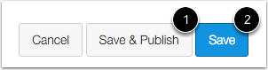
- Save and Publish

- If you are ready to publish your discussion, click the Save & Publish button [1].
- If you want to create a draft of your discussion and publish it later, click the Save button [2].
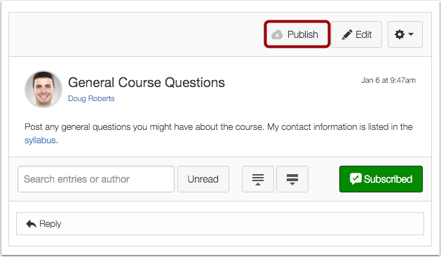
- When your discussion is saved in a draft state, you can return to the page and publish it at any time by clicking the Publish button.

- View Discussion
