Creating A Sandbox Course for Each 2016-17 Course Taught

- Log into your Canvas account.

- You should be on the Dashboard page.

- Select the “Start a New Course” button on the RIGHT side of your Canvas window:
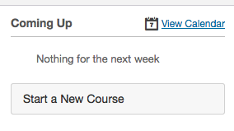

- Type in the following:
1. Course Name:
2017-18 SANDBOX ______________________
Example:
“2017-18SANDBOX ADVANCED EARTH SCIENCE”

2. Short Name: 17-18SB ADV EARTH SC
*Use “17-18SB” then an abbreviated version of your course. This will display across the top of your Canvas course in the breadcrumb trail & will make management easier for you. Short is better.

3. Content License-Select “Private (Copyrighted)”

4. Do not make it visible publicly due to copyrighted material you may be using.

5. Select “Create Course”
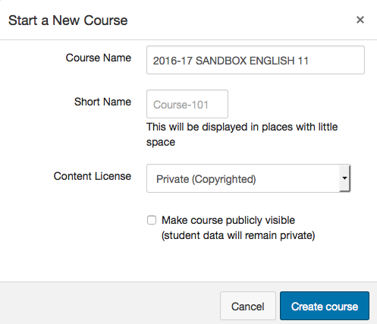

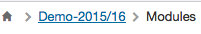
*Breadcrumb trail you will see

- You will repeat this process for each 16-17 course you have created content in this year so that it will be available for the 17-18 school year.

