How Do I Import Content from Another Course into my Official Course with Students?
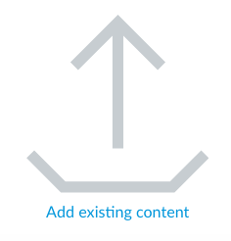
- Select the empty course to which you want to add content. The image below should be on the course homepage. Click on this image “Add existing content.”

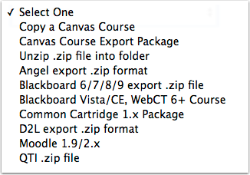
- Choose Import Source:
Select Copy a Canvas Course
& browse for the name of the course to copy into your new course.

- Select All Content.
- If you do NOT want ANY dates imported from the last school year, see Step #6 below BEFORE importing.
FOR USERS WHO HAVE CANVAS COURSES WITH DATES SET FROM THE PREVIOUS SCHOOL YEAR…
- Adjust Events and Due Dates:

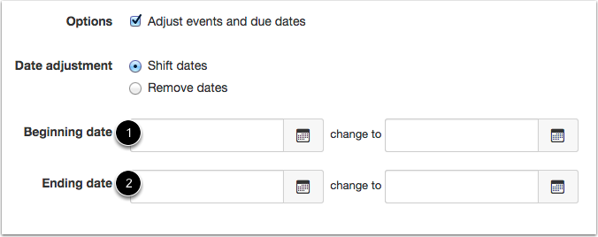
(NOTE: Be sure you have not already adjusted due dates for the upcoming school year in your sandbox course.)

- In addition to recreating the structure and content of the course, the Course Import Tool will intelligently re-schedule due dates and calendar events to the new date ranges of the new semester/school year.
- Enter the beginning and end dates of the old course/semester [1] if they are not already set, and then enter the dates of the new course/semester [2].
- If you copy a Canvas course with beginning and end dates, those dates will be pre-populated in the initial date fields.
- Note: You must enter both sets of beginning and end dates as accurately as possible for the dates to adjust correctly. Varied Due Dates will not be adjusted during the import.
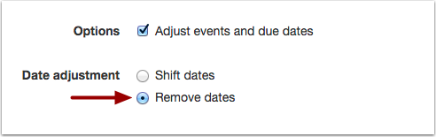
- To Remove Dates:
Dates will be removed from the following features:
- Assignments (due, availability, and peer-review dates)
- Announcements (post delay dates)
- Quizzes (due, availability, and show correct answers dates)
- Calendar events (start and end dates)
- Modules (unlock dates)

- Select Import (The import will say “running.” You can leave this page and work on other items in Canvas or import other courses.)

