LanSchool: Web Limiting Directions

Web Limiting:

- Open LanSchool Teacher.

- Go to:
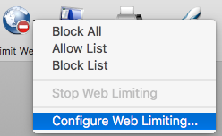
Limit Web & drop down on the menu to select
“Configure Web Limiting…”

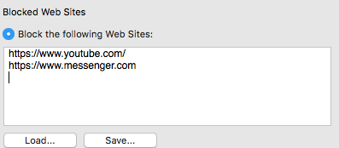
- In this window, select “Blocked Web Sites”
Copy & Paste the URL(s) you want to BLOCK.

See example left.

Select “Save”

- Browse the place on your laptop that you have your LanSchool folder.

- *Make a “Web Limiting” folder if you don’t have one.
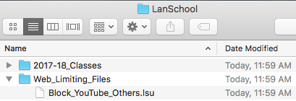

*Name the file something that makes sense. My example file has both YouTube and Messenger (Facebook Messenger) sites blocked.

- Close out of this window where you saved the Web Limiting file.

- Launch your class in LanSchool if you haven’t already.

- Select Limit Web and go to Block List:
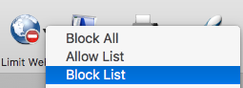
NOTE: If you set up different Blocked List files, you will need to browse for the correct file.

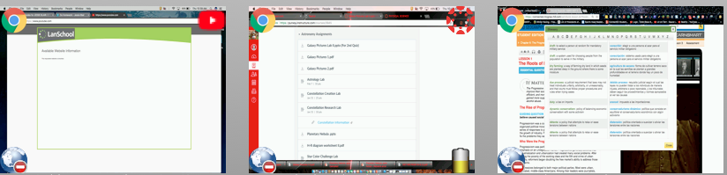
- Example of what you will see: The symbol at the bottom left of each screen shows that Web Limiting is on.
This student is on Chrome (top left) and reading something for an assignment online (top right).

This student is on Chrome (top left) and trying to get on YouTube (top right).
LanSchool blocks YouTube with this message.

This student is on Chrome (top left) and Canvas (top right).

- To allow a student access to a site you have blocked while still blocking others, just select the student’s screen (It will be highlighted in RED), go to Web Limiting and select “Stop Web Limiting.” It will allow just that student to use whatever you have blocked for the rest of the class.

