Issues with MacBooks & Whiteboard Projection: Directions for Fix

PROBLEM:
The “galaxy” background picture displays when you plug into the whiteboard & NOTHING else shows up on the whiteboard.

SOLUTION:
- Plug the laptop into the Projector by using the white dongle.
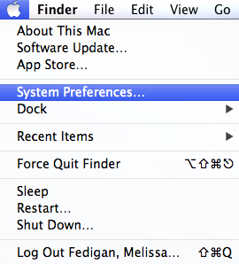
- On the laptop, go to the “Apple” (top, left corner)

- Drop down to “System Preferences”

- In the next window, select “Displays”

- Follow Directions for each “Tab” in the “Display” window

- Arrangement—Go to this tab first! Be sure the “Mirror Image” box is checked!
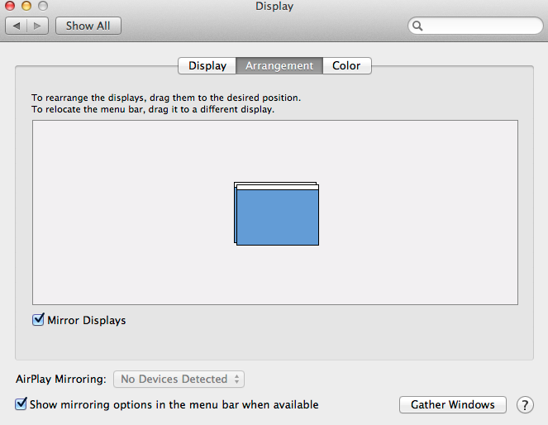

- Display—Be sure the resolution is 1024 X 768, 60 Hz-if not, select, say “ok,” & “confirm” for this setting to stay.

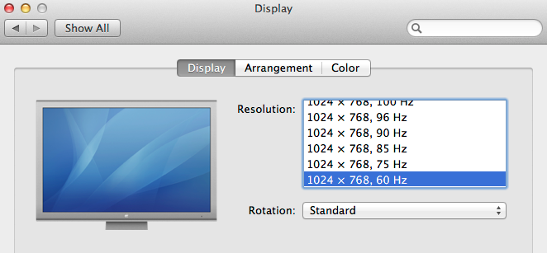

- Color—deselect “Show Profiles for This Display Only” & a list will appear—select “Adobe RGB 1998” if you need the screen lightened to see a movie or a dark picture!
