To Print from IEP Writer

- Open up Firefox
- Drop down to Firefox Preferences:
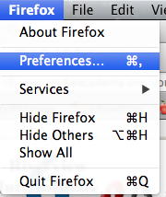

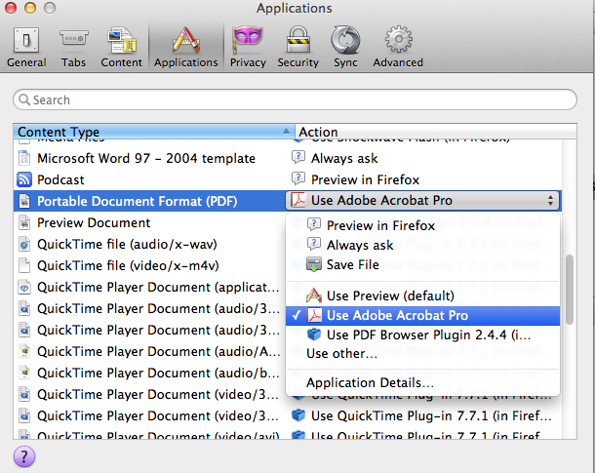
- Once in Preferences, select the “Applications” tab
4. Scroll through the “Content Type” list until you find “Portable Document Format (PDF)

5. Under “Action”—drop down & select “Use Adobe Acrobat Pro” (you may have to select “use other” & browse for this, if it isn’t in your drop down list.)

