Download Files to the Desktop

Safari:
- Go to Safari-Preferences.
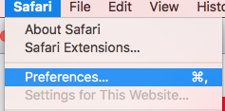

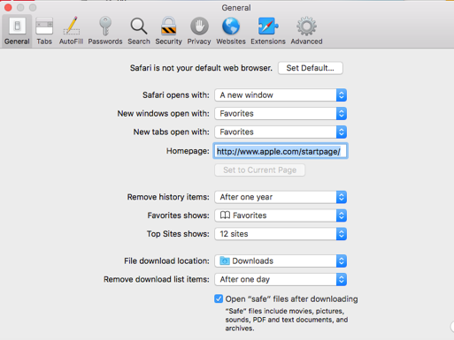
- Select the “General” tab across the top menu bar.

- Browse to select a new file download location, such as your desktop.

Chrome:
- Go to Chrome-Preferences.
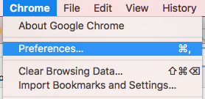

- Either search for “Downloads” in the settings search tool or scroll through the page to it.
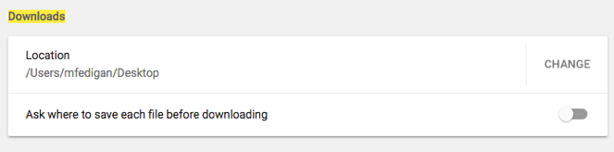
- Select “change” to select a new location for your downloaded files.

